APPLICATION FORM FOR JAPAN’S TECHNICAL COOPERATION
- Date of Entry: Day _____ Month Year
- Applicant: The Government of
- Technical Cooperation (T/C) Title:
- Type of the T/C ^Select only one scheme.
- Technical Cooperation Project / Technical Cooperation for Development Planning
- Science and Technology Research Partnership for Sustainable Development (SATREPS)
- Individual Expert □ Individual Training
- Contact Point (Implementing Agency):
Address:
Contact Person:
Tel. No.: Fax No.
E-Mail:
- Background of the T/C
(Current conditions of the sector, Government’s development policy for the sector, Issues and problems to be solved, Existing development activities in the sector, the Project’s priority in the National Development Plan / Public Investment Program, etc.)
- Outline of the T/C
- Overall Goal
(Long-term objective)
- T/C Purpose

(Objective expected to be achieved by the end of the project period. Elaborate with quantitative indicators if possible)
(3) Outputs
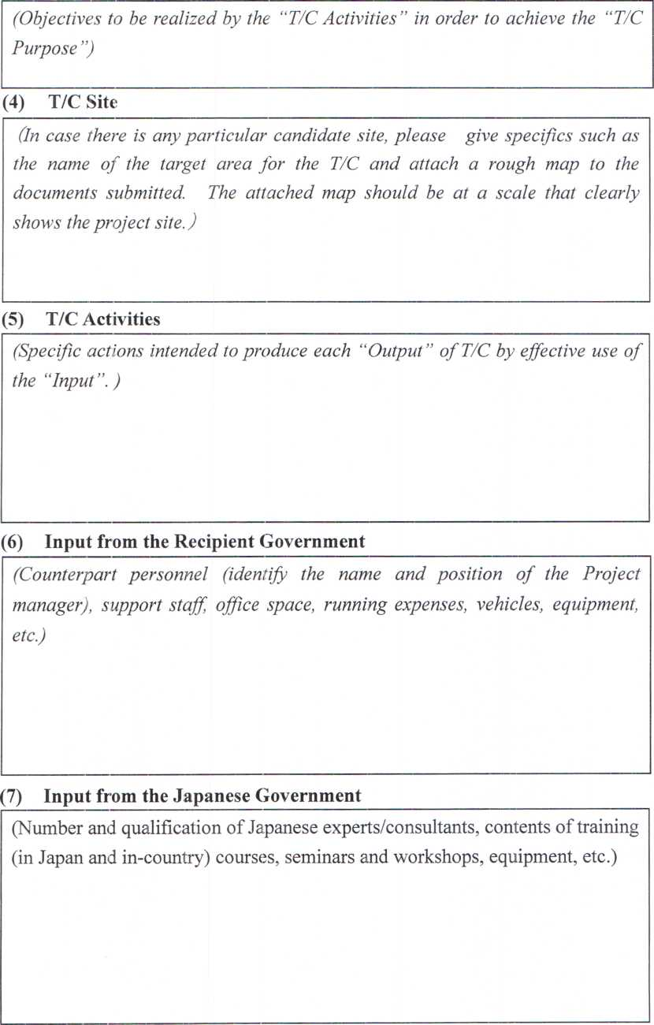

- Implementation Schedule
Month Year
Month
Year

- Description of an Implementing Agency
(Budget allocated to the Agency, Number of Staff of the Agency, Department/division in charge of the T/C, etc.)
- Related Information
- Prospects of further plans and actions/ Expected funding resources for the Project:
(If implementing agency plans to take some (future) actions in connection with this proposed project, please describe the concrete plans/action and enter the funding sources for the plans and actions.)
- Activities in the same sector of other donor agencies, the recipient government and NGOs and others:
(Please pay particular attention to the following items:
—Whether you have requested the same project to other donors or not.
—Whether any other donor has already started a similar project in the target area or not. —Presence/absence of cooperation results or plans by third-countries or international agencies for similar projects.
—In the case that a project was conducted in the same field in the past, describe the grounds for requesting this project/study, the present status of the previous project, and the situation regarding the technology transfer.
—Whether there are existing projects/studies regarding this requested project/ study or not. (Enter the time/period, content and concerned agencies of the existing studies.))
- Global Issues (Gender, Poverty, Climate change, etc.)
(Any relevant information of the project from global issues (gender, poverty, climate change, etc.) perspective.)
- Environmental and Social Considerations
(In case of Technical Cooperation Project (including SATREPS) / Technical Cooperation for Development Planning, please fill in the attached screening format.)
(Note) If JICA considers that the environmental and social considerations are required to the T/C, the applicants agree on JICA’s information disclosure of the T/C for public
Signed:_
Title:
13. Others
On behalf of the Government of
Date:
Additional Form for Expert
^If the applicants select the Individual Expert in 4. , this form needs to be filled out.
- Type of Assignment
(New / Extension / Successor)
If this type is “Extesion” or “Successor”, please show whose extension or successor it is.
- Qualifications and Experience required
- Age Limit
- Educational Background (Doctor / Master / Bachelor)
- Practical Experience on Related Field
- Language (Name / Level)
- Other Qualification and Experience
Additional Form for SATREPS
5^If the applicants select the SATREPS in 4., please fill out this form.
- Japanese Partner of SATREPS
- Research Institutions :
- Principal Investigator of Japanese sicle :
- Other Researchers :
- Institutional profile
- Research Institutions :
- Principal Investigator :
- Previous international joint research projects related this SATREPS (Give their titles in English) If the projects are supported by other agencies, provide agency names, and years.
(Title of the project) | (Name of the agency) | (Year)

(4)Current research projects related this SATREPS (Give their titles in English) If the projects are supported by other agencies, provide agency names, and years)
(Title of the project) | (Name of the agency) | (Year)

3. List of available equipment for the proposed research
(Name of equipment) | (Specification /type and performance) | Exclusive/ Joint Use | (FY of Installation)

Please write “to be advised (TBA)” when the details of a project are yet to be determined. Question 1: Address of project site
Question 2: Scale and contents of the project (approximate area, facilities area, production, electricity generated, etc.)
2-1. Project profile (scale and contents)
2-2. How was the necessity of the project confirmed?
Is the project consistent with the higher program/policy?
□YES: Please describe the higher program/policy.
( ) □NO
2-3. Did the proponent consider alternatives before this request?
□YES: Please describe outline of the alternatives
( ) □NO
2-4. Did the proponent implement meetings with the related stakeholders before this request?
□Implemented nNot implemented
If implemented, please mark the following stakeholders.
□Administrative body □Local residents □NGO
□Others ( )
Question 3:
Is the project a new one or an ongoing one? In the case of an ongoing project, have you received strong complaints or other comments from local residents?
CK'ew COngoing (with complaints) ^Ongoing (without complaints)
□Other /" ~\
Question 4:
Is an Environmental Impact Assessment (EIA), including an Initial Environmental Examination (IEE) Is, required for the project according to a law or guidelines of a host country? If yes, is EIA implemented or planned? If necessary, please fill in the reason why EIA is required.
□Necessity (□Implemented nOngoing/planning)
(Reason why EIA is required: )
□Not necessary
- Other (please explain)
Question 5:
In the case that steps were taken for an EIA, was the EIA approved by the relevant laws of the host country ? If yes, please note the date of approval and the competent authority.

□Under appraisal
□Approved without a supplementary condition □Approved with a supplementary condition
(Date of approval: Competent authority: )
□Under implementation □Appraisal process not yet started
□Other ( )
Question 6:
If the project requires a certificate regarding the environment and society other than an EIA, please indicate the title of said certificate. Was it approved?
□Already certified
Title of the certificate: ( )
□Requires a certificate but not yet approved □Mot required
□Other C
Question 7:
Are any of the following areas present either inside or surrounding the project site?
□Yes □Mo
If yes, please mark the corresponding items.
□National parks, protection areas designated by the government (coastline, wetlands, reserved area for ethnic or indigenous people, cultural heritage)
□Primeval forests, tropical natural forests
□Ecologically important habitats (coral reefs, mangrove wetlands, tidal flats, etc.) □Habitats of endangered species for which protection is required under local laws and/or international treaties □Areas that run the risk of a large scale increase in soil salinity or soil erosion □Remarkable desertification areas
□Areas with special values from an archaeological, historical, and/or cultural points of view
□Habitats of minorities, indigenous people, or nomadic people with a traditional lifestyle, or areas with special social value
Question 8:
Does the project include any of the following items?
□Yes □No
If yes, please mark the appropriate items.
□Involuntary resettlement (scale:
households persons)
m3/year)
land-clearing (scale: hectors)
hectors)
□Groundwater pumping (scale:
□Land reclamation, land development, and/or □Logging (scale:
Question 9:
Please mark related environmental and social impacts, and describe their outlines.
- Air pollution
- Water pollution
- Soil pollution
- Waste
□Noise and vibrations
- Ground subsidence
- Offensive odors
- Geographical features
- Bottom sediment
- Biota and ecosystems
- Water usage □Accidents
- Global warming
□Involuntary resettlement
□Local economies, such as employment,
livelihood, etc.
- Land use and utilization of local resources
- Social institutions such as social infrastructure and local decision-making institutions
- Existing social infrastructures and
services
- Poor, indigenous, or ethnic people □Misdistribution of benefits and damages □Local conflicts of interest
- Gender
- Children’s rights
- Cultural heritage
- Infectious diseases such as HIV/AIDS
- Other ( )
Outline of related impact:
Question 10:
In the case of a loan project such as a two-step loan or a sector loan, can sub-projects be specified at the present time?
□Yes □No
Question 11:
Regarding information disclosure and meetings with stakeholders, if JICA’s environmental and social considerations are required, does the proponent agree to information disclosure and meetings with stakeholders through these guidelines?
□Yes DNo

